Pakistan J. Zool., vol. 43(3), pp. 563-567, 2011.

Nest-site Characteristics of the Blue-eared Pheasant in northwest China

Wu Yi-qun¹* and Liu Nai-fa²
¹Department of Environment and Life Sciences, Weinan Teachers University, Weinan, Shaanxi 714000
²School of Life Sciences, Lanzhou University, Tianshui Road 222, Lanzhou, Gansu, China. 730000

Abstract.- From 2007 to 2008 we studied the nest-site characteristics of Blue-eared Pheasants (Crossoptilon auritum) in northwest China. Of 12 nests found, four (33.3%) were located under conifers, four (33.3%) in rock and cave sites, two (16.7%) under fallen trees, and two (16.7%) in thick shrubs. The degree of concealment was highest from the rear of nests (90.8%), followed by the top, left, right, and front. We also assessed 13 habitat variables at nest sites (n=12) and control sites (n=24). Nest-sites on southeast, south and west slopes were selected as nest-sites with higher slope positions and steeper slope gradients. Stepwise discriminate analysis indicated that the Blue-eared Pheasant selected to nest in habitats with higher vegetation cover at heights of 1 m and 2 m, lighter disturbance and higher slope position.

Key words: Blue-eared pheasant, Crossoptilon auritum, Gahai-zecha Nature Reserve, nest-site characteristics, stepwise discriminate analysis.

INTRODUCTION

Nest-site selection is an important factor influencing the survival and reproductive success of birds (Badyaev, 1995; Clark and Nudds, 1991), because habitat provided by the nesting environment can affect the mortality rate of nestlings (Martin, 1995; Clark and Shutler, 1999). The studies indicated nest-site selection for one agnate bird was always similar preference, but the characteristics of the nest often vary with different habitat types, likely due to the adaptive strategy of a species under different environmental pressures (Nguyen et al., 2004). Nest success depends on predators, weather, quality of female, and the position of the nest (Batt et al., 1992; Flint and Grand, 1996; Traylor et al., 2004).
The Blue-eared Pheasant (Crossoptilon auritum) is endemic to China and is mainly found in the east and northeast Qinghai Province, northwest and south Gansu Province, northwest Sichuan Province, and west Ningxia Autonomous Region (Lu et al., 1998). The four species of eared pheasants (Crossoptilon spp.) are usually found in forest habitats (Johnsgard, 1999), but the Blue-eared Pheasant also occurs in relatively sparse shrub
_____________________________
* Corresponding author. wuyq-05@163.com
0030-9923/2011/0003-0563 $ 8.00/0
Copyright 2011 Zoological Society of Pakistan.
vegetation typical of sub-alpine shrub meadows (Li et al., 1985). The Blue-eared Pheasant is known to nest on the ground; however, nest-site selection has not been systematically studied. More detailed knowledge of nest site habitat selection is crucial to proper conservation of this species. Therefore, the goals of this study were to measure characteristics of Blue-eared Pheasant nesting habitat, and to identify key variables influencing nest-site selection.

MATERIALS AND METHODS

Study area
This study was conducted in southern Gansu Province, northwest China during the 2007-2008 breeding season. The study area is located in the Gaihai-zecha National Nature Reserve (102°05′ - 102°47′E, 33°58′ - 34°32′N). Logging activity has been strictly prohibited here for ten years. Two main habitat types dominate the nature reserve: cold-temperate coniferous forest characterized by spruce (Picea asperata) and fir (Abies sp.), and mountain-temperate coniferous forests with Qilian Juniper (Sabina przewalskii) distributed on south slopes. The local forest is characterized by closed canopy with an elevation from 3 000 to 3 500 m. Closed-canopy areas are interspersed with gaps containing shrubs and meadows (Wu and Liu, 2010).

Data collection
Field data were collected during 2007 and 2008. During each breeding season (from late March to mid-June), random transect lines were walked throughout the valley in the area of 3 000 hm² at a speed of 1.5 km/h to investigate the nest utilization of the pheasant. Once a nest had been found within 100 m of either side of transect, the nest was used as the center of a square 10×10 m sample plot. Each 10×10 m plot was divided into four 2×2 m plots which located in four angle of nest-site sample, and five 1×1 m plots which located in quarter cater-corner and centre of nest-site sample (Xu et al., 2002; Chen et al., 2009; Li et al., 2010) (Fig 1). Two control samples for each nest-site were selected at sites 40 and 100 m away from the nest site in random directions (Jiang et al., 2006; Liao et al., 2007). If the parameters of control samples site could not be measured (e.g. cliff, river and so on), another random direction would be select.

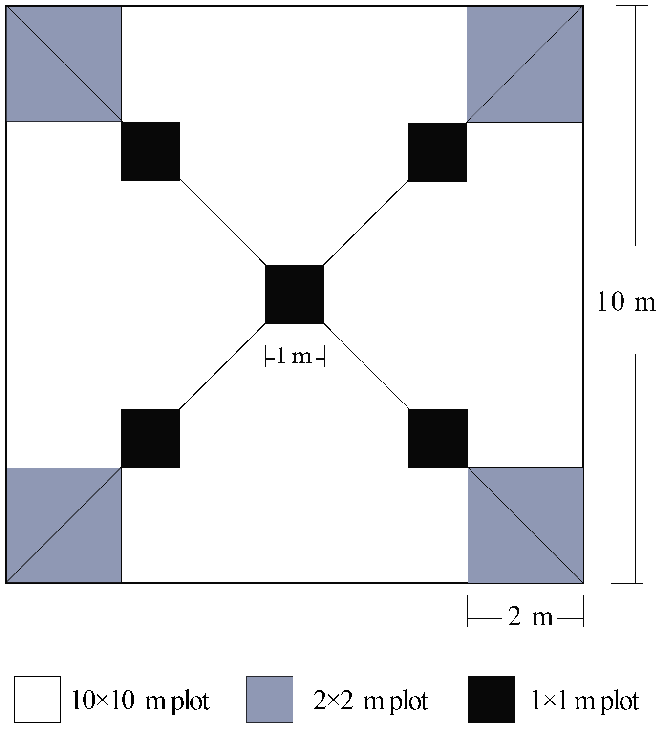

Fig. 1. The sampling scheme of 10×10 m, 2×2 m and 1×1 m plots.

In 10×10 m samples, the following parameters were measured: altitude (measured by GPS), slope direction (measured with GPS, east=1, southeast=2, south=3,….. northeast=8) (Chen et al., 2009), slope position (divided into low, mid-low, medium, mid-high, high valuing from 1 to 5, respectively), slope gradient (°) (measured by compass), distance to water (m), distance to road (m), distance to open area (m), distance to forest edge (m), distance to ridge (m), tree height (m) (diameter 10cm, average height was measured with tape measure), tree diameter (cm) (diameter 10cm, average diameter measured with an altimeter from the ground to the top of the canopy), number of tree (diameter 10cm), canopy cover (%), 0.5 m vegetation cover (%), 1.0 m vegetation cover (%), 2.0 m vegetation cover (%), 4.0 m vegetation cover (%), disturbance level. In 2×2 m plots, we measured shrub height (m) (average height was measured with a scale ruler), number of shrubs, shrub cover (%), and species richness (all species type of shrub and grasses). In 1×1 m plots, we measured grass height (cm) (average height was measured with a scale ruler), grass density (per m²), and grass cover (%). For those sample plots, percent cover was estimated with an ocular tube. Judging by activity frequency of local people and livestock in 10×10 samples, disturbance level divided into none (appearance frequency: 0/day), light (1-5/day), moderate (6-10/day), serious (11-20/day), extraordinary serious (20/day) valuing from 1 to 5.
As all of the nests we found were located beside a rock wall and a shrub root, we treated the rock and the root as the back of the nest and measured the distance to overhead vegetation (cm), distance to vegetation edge (cm), and the degree of concealment (%) of the front, back, left, right, and overhead sides of the nest. Percent concealment was visually estimated by placing a 20×20 cm piece of white paper in the middle of the nest and observing the paper from 1 m away from the nest in each direction.

Data analysis
To examine differences for each variable between control and nest sites, we used parametric procedures (T test) when data were normally distributed (by Kolmogorov–Smirnov Z test, P>0.05), and non-parametric procedures (Mann–Whitney U-tests) when they were not. Correlation between significant variables was estimated with

Table I.- Nests characteristics of Blue-eared pheasant (n=12).

Variable | Minimum | Maximum | Mean±SD
Distance to overhead vegetation (cm) | 20 | 60 | 36.25 ±12.17
Distance to vegetation edge (cm) | 20 | 180 | 76.08 ±46.15
Front concealment (%) | 10 | 85 | 45.42 ±26.06
Rear concealment (%) | 35 | 100 | 90.83 ±18.69
Left concealment (%) | 20 | 90 | 66.25 ±23.27
Right concealment (%) | 10 | 100 | 49.17 ±31.90
Overhead concealment (%) | 30 | 100 | 83.75 ±23.17

Spearman’s rank correlation coefficient. Stepwise-forward discriminate function analysis (DFA) was employed to determine which variables had major influences on nest-site habitat selection (Xu et al., 2002; Li et al., 2010). To examine differences among nest sites types, χ² test was used. All results are shown as mean ± SD. We used SPSS 15.0 for Windows software to conduct all statistical analysis.

RESULTS

Nest-sites characteristics
All of the nests were concealed by shrubs, rock walls, or fallen branches. Nests were shallow depressions lined with sticks and feathers. Of 12 nests found, four (33.3%) were located under rock walls and covered by shrubs, four (33.3%) were under trees, two (16.7%) were under fallen trees, and two nests were under shrubs (16.7%). However, chi-squared tests showed that there are not significant differences among nest site types (χ² =1.333, df =3; P = 0.721). Nest site characteristics are shown in Table I.

Parametric and non-parametric procedures
Elevations of Blue-eared Pheasant nest sites ranged from 3 022 to 3 306 m. However, there were no significant elevation differences between nest-sites and control-sites. Blue-eared Pheasants selected to nest on steep slopes (Z = -2.64, df = 11, P < 0.01). No nests were located on slopes shallower than 30°. Sites on southeast, western and southern accounted for 66.7%.
Vegetation coverage at 0.5 m, 1.0 m and 2.0 m, and the height, number, and percent shrub cover was significantly higher at nest sites than at control sites. This suggests that Blue-eared Pheasants selected areas with more cover under 2 m and select thick vegetation in which to nest. The analysis also showed that disturbance levels were significantly lower at nest sites than at control sites, indicating that pheasants avoided areas disturbed by livestock and local residents.

The stepwise discriminate analysis
We found significant differences between nest and control sites in slope position, slope gradient, shrub height, number of shrubs, shrub cover, 0.5 m cover, 1.0 m cover, 2.0 m cover, and disturbance level (Table II). Of these variables, using Spearman correlation analysis, we selected slope position, slope gradient, shrub number, 1.0 m cover, 2.0 m cover and disturbance level for use in stepwise discriminate analysis (Table III). Of these six variables, differences in disturbance level, 1.0 m cover, 2.0 m cover and slope position between nest and control sites indicated that the Blue-eared Pheasant preferred to nest in habitats with more vegetation cover at heights of 1.0 m and 2.0 m, lighter disturbance and higher slope position.

DISCUSSION

Several variables did not show significant differences between control sites and nest sites (e.g., number of tree, tree cover, grass density, grass cover, etc.). In the Zecha reserve, the conifer forest canopy obstructs sunshine, preventing shrub growth and providing few optimal habitats for nesting. Most nest sites were located in the shrubby gaps created by fallen trees and rock walls.
Habitat selection, particularly nest-site selection, depends primarily on small-scale vegetation structure, such as vegetation cover,

Table II.- Variables comparison between nest-sites and control sites of Blue-eared pheasant.

Variables | Nest-site (n=12) | Control site (n=24) | Z | T | P value
Altitude (m) | 3207.58 ± 86.19 | 3177.88 ± 75.67 |  | 0.897 | 0.379
Slope direction | 5.42 ± 2.07 | 4.96 ± 2.01 |  | 0.552 | 0.587
Slope position | 3.83 ± 1.11 | 2.79 ± 0.72 | -2.349 |  | 0.019﹡
Slope gradient (°) | 66.67 ± 13.71 | 53.54 ± 10.84 | -2.640 |  | 0.008﹡﹡
Distance to water (m) | 210.00± 206.91 | 257.71 ± 227.37 |  | -0.538 | 0.596
Distance to road (m) | 66.25 ± 41.18 | 84.38 ± 50.96 |  | -0.958 | 0.348
Distance to open area (m) | 158.33 ± 151.95 | 167.50 ± 148.86 |  | -0.149 | 0.883
Distance to forest edge (m) | 180.67 ± 115.91 | 144.38 ± 101.61 |  | 0.816 | 0.423
Distance to ridge (m) | 47.50 ± 60.96 | 56.67 ± 52.24 |  | -0.396 | 0.696
Tree height (m) | 6.14 ± 3.21 | 5.64 ± 1.79 |  | 0.475 | 0.640
Tree diameter (cm) | 11.28 ± 4.35 | 8.98 ± 3.72 |  | 1.393 | 0.178
Number of tree | 9.50 ± 9.32 | 7.21 ± 6.82 |  | 0.687 | 0.499
Canopy cover (%) | 19.83 ± 15.36 | 16.21 ± 10.55 |  | 0.674 | 0.507
Shrub height (m) | 1.26 ± 0.55 | 0.74 ± 0.27 | -2.409 |  | 0.016﹡
Number of shrubs | 9.66 ± 5.41 | 5.80 ± 4.46 | -2.311 |  | 0.021﹡
Shrub cover (%) | 36.96 ±17.11 | 22.85 ± 10.6 |  | 2.422 | 0.024﹡
Grass height (cm) | 13.67 ± 4.75 | 14.71 ± 4.89 |  | -0.531 | 0.601
Grass density (/m²) | 55.42 ± 65.67 | 73.59 ± 62.51 |  | -0.695 | 0.495
Grass cover (%) | 43.08 ± 19.89 | 36.04 ± 12.97 |  | 1.027 | 0.317
0.5 m vegetation cover (%) | 38.75 ± 19.67 | 25.13 ± 11.26 |  | 2.083 | 0.049﹡
1.0 m vegetation cover (%) | 36.58 ±16.48 | 20.75 ± 7.00 | -2.461 |  | 0.014﹡
2.0 m vegetation cover (%) | 35.83 ± 22.05 | 16.42±6.27 | -2.169 |  | 0.030﹡
4.0 m vegetation cover (%) | 15.42 ± 10.10 | 16.96±13.14 |  | -0.322 | 0.750
Species richness | 9.33 ± 2.49 | 7.92±2.50 |  | 1.388 | 0.179
Disturbance level | 1.92 ± 0.90 | 3.33±0.57 | -3.406 |  | 0.001﹡﹡
*P<0.05; **P<0.01; Z: Mann–Whitney U test; T: Independent-samples t test.

Table III.- Correlation coefficients for the significant different variables of nest-sites.

Variables | SLP | SLG | SHH | SHN | SHC | VEC-0.5m | VEC-1.0m | VEC-2.0m | DIL
SLP | —
SLG | -0.509 | —
SHH | -0.481 | 0.643* | —
SHN | -0.040 | 0.096 | -0.332 | —
SHC | -0.771** | 0.769** | 0.707* | 0.002 | —
VEC-0.5m | -0.102 | -0.178 | 0.039 | 0.139 | 0.150 | —
VEC-1.0m | 0.092 | 0.029 | 0.238 | 0.004 | 0.025 | 0.737** | —
VEC-2.0m | 0.162 | 0.179 | 0.304 | -0.138 | 0.088 | 0.462 | 0.893** | —
DIL | 0.258 | -0.321 | -0.422 | -0.076 | -0.365 | 0.304 | 0.118 | -0.131 | —
Note: 1. SLP: Position on slope; SLG: Slope gradient; SHH: Shrub height; SHN: Number of shrubs; SHC: Shrub cover; VEC-0.5m: 0.5 m vegetation cover; VEC-1.0m: 1.0 m vegetation cover; VEC-2.0m: 2.0m vegetation cover; DIL: Disturbance level.
2. *P<0.05; **P<0.01.

height, and density (Badyaev, 1995; Robertson, 1995; Pechacek and d'Oleire-Oltmanns, 2004). For pheasant species, many studies have shown that refuge provided by the habitat is important for nest-site selection (Lu and Zheng, 2003; Nguyen et al., 2004). In this study, all nests were covered by shrubs. Five different directions of the nest-sites had more cover (range 45.4–90.8%) (Table I). The vegetation cover at 0.5 m, 1.0 m, and 2.0 m above the ground were significantly higher in nest samples than in control samples, suggesting that nest sites do provide refuge from predation during incubation.
This study showed that most of the nests of Blue-eared Pheasant were located higher on slopes (P <0.05) that were steeper (P <0.001) than control sites. This may aid in rapid escape from approaching predators. Slope degree has also been shown to affect nest-site selection in White-eared Pheasants (Wang et al., 2005). In addition, stepwise discriminate analysis showed that the disturbance level and slope position were the most important ecological factors influencing nest-site selection. In the field habitats of our study area, 83.3% of nests were located on middle and upper slopes, possibly as a result of local grazing, deforestation and other human activities. In the forested parts of our study area, nest sites were ostensibly protected by the surrounding chain-link fence; however, this wire was frequently destroyed by local herdsmen to allow livestock grazing. Disturbances on lower slopes may have contributed to the pheasants’ apparent preference for higher slopes.

ACKNOWLEDGEMENTS

This study was funded by National Natural Science Foundation of China (30530130), Natural Science Basic Research Project in Shaanxi Province (2010JQ3001), Scientific Research Program funded by Shaanxi Provincial Education Department (2010JK543) and Graduate Program of Weinan Teachers University (10YKZ055). We appreciate the improvements in English usage made by Christina Riehl of Princeton University.

REFERENCES

Badyaev, A.V., 1995. Nestling habitat and nestling success of eastern wild turkeys in the Arkansas Ozark high lands. Condor, 97: 22l-232.
BatT, B.D.J., Afton, A.D., Anderson, M.G., Ankney, C.D., Johnson, D.H., Kadlec, J.A. and Krapu, G.L., 1992. Ecology and management of breeding waterfowl. University of Minnesota Press, Minneapolis.
CHEN, J.H., Huang, X.F., Lu C.H., Yao, X.H. and She, Z.P., 2009. Spatial niches of Syrmaticus ellioti and Lophura nycthemera in autumn and winter. Chin. J. Ecol., 28: 2546-2552.
Clark, R.G. and Nudds, T.D., 1991. Habitat patch size and duck nesting success: the crucial experiments have not been undertaken. Wildl. Soc. Bull., 19: 534–543.
Clark, R.G. and Shutler, D., 1999. Avian habitat selection: pattern from process in nest-site use by ducks? Ecology, 80: 272-287.
Flint, P.L. and Grand, J.B., 1996. Nesting success of northern pintails on the coastal Yukon-Kuskokwim Delta, Alaska. Condor, 98: 54-60.
Jiang, A.W., Zhou, F., Lu, Z., Han, X.J., Sun, R.J. and Li, X.L., 2006. Roost-site selection of Mrs Hume’s pheasant (Syrmaticus humiae) in Guangxi, China. Zool. Res., 27: 249-254.
Johnsgard, P.A., 1999. The pheasants of the world, 2nd. Smithsonian Institution Press, Washington, DC.
Li, G.Y., Zhang, R.Y., Liu, C.Y., Zhang, Q.M., Hu, T.Q. and Wang, C.H., 1985. Observation of blue-eared Pheasant in Wanglang Nature Reserve, Sichuan. Sichuan J. Zool., 4:7-9, 33.
Li, H.Q., Lian, Z.M. and Chen, C.G., 2010. Winter foraging-sites selection of brown-eared pheasant in Huanglong Mountains Nature Reserve. J. Northw. Norm. Univ. (Nat. Sci.), 46:94-98.
Liao, W.B., Li, C., Hu, J.C. and Lu, X., 2007. Habitat utilization of the Sichuan Hill partridge (Arborophila rufipectus) in the non-breeding period in Laojunshan Nature Reserve. Zool. Res., 28:172-178.
Lu, X. and Zheng, G.M., 2003. Reproductive ecology of Tibetan eared pheasant Crossoptilon harmani in scrub environment, with special reference to the effect of food. Ibis, 145: 657-666.
Lu, X., Zheng, G.M. and Gu, B.Y., 1998. Preliminary investigation on taxonomy, distribution and evolutionary relationship of the eared pheasants, Crossoptilon. Acta zool. Sin., 44:131-137.
Martin, T.E., 1995. Avian life-history evolution in relation to nest sites, nest predation, and food. Ecol. Monogr., 65: 101-127.
Nguyen, L.P., Hamr, J. and Parker, G.H., 2004. Nest site characteristics of Eastern Wild Turkeys in central Ontario. Northeas. Nat., 11: 255-260.
Pechacek, P. and d'Oleire-Oltmanns, W., 2004. Habitat use of the three toed woodpecker in central Europe during the breeding period. Biol. Conserv., 116: 333-341.
Robertson, G.Y., 1995. Factors affecting nest site selection and nesting success in the common eider Somateria mollissima. Ibis, 137:109-115.
Traylor, J.J., Alisauskas, R.T. and Kehoe, F.P., 2004. Nesting ecology of white-winged scoters Melanitta fusca deglandi at Redberry Lake, Saskatchewan. Auk., 121: 950-962.
Wang, N., Jia, F. and Zheng, G.M., 2005. Study on nest-site selection of white-eared pheasant (Crossoptilon crossoptilon). J. Beijing Norm. Univ. (Nat. Sci.), 41: 190-193.
Wu, Y.Q. and Liu, N.F., 2010. Nest site selection of blue-eared pheasant (Crossoptilon auritum) in south Gansu, China. Chin. J. Ecol., 29: 1393-1397.
Xu, J.L., Zhang, X.H., Zhang, Z.W. and Zheng, G.M., 2002. Brood habitat characteristics of Reeve’s pheasant (Syrmaticus reevesii) in Dongzhai National Nature Reserve. Zool. Res., 23: 471-476.

(Received 30 April 2010, revised 17 October 2010

